**Installation instructions for the R, R studio and required packages**

1. Download and install the latest version of R (currently 3.4.0) for your platform [here](https://cran.r-project.org/) (https://cran.r-project.org/). Accept all default options during installation.
2. Download and install the latest version of Rstudio desktop (currently 1.0.143) for your platform [here](https://www.rstudio.com/products/rstudio/download) (https://www.rstudio.com/products/rstudio/download/). Again, accept all default options during installation.
3. Now launch Rstudio. You should see a screen similar with this. Check that the text in the **Console** pane reads R version 3.4.0.

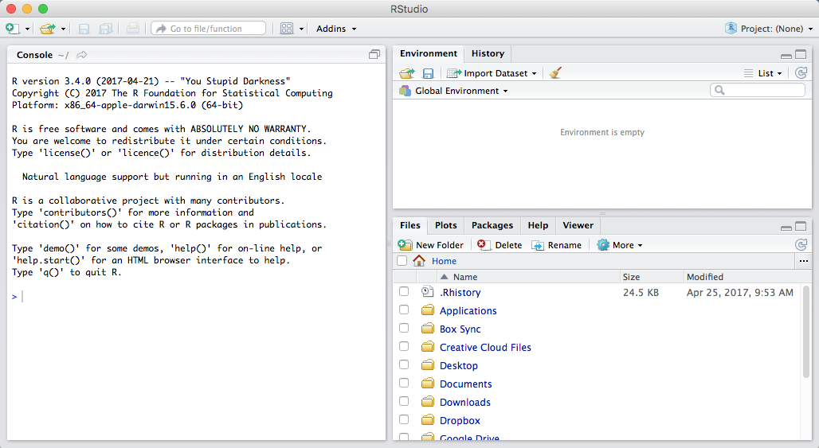

1. Install required packages. To do so: Rstudio through the **File > Open File…** > select the attached R script, ‘**Install required packages_P3-IntroStat.R**’ Press the **'Source'** button in the top right corner of the script pane (as captures below).

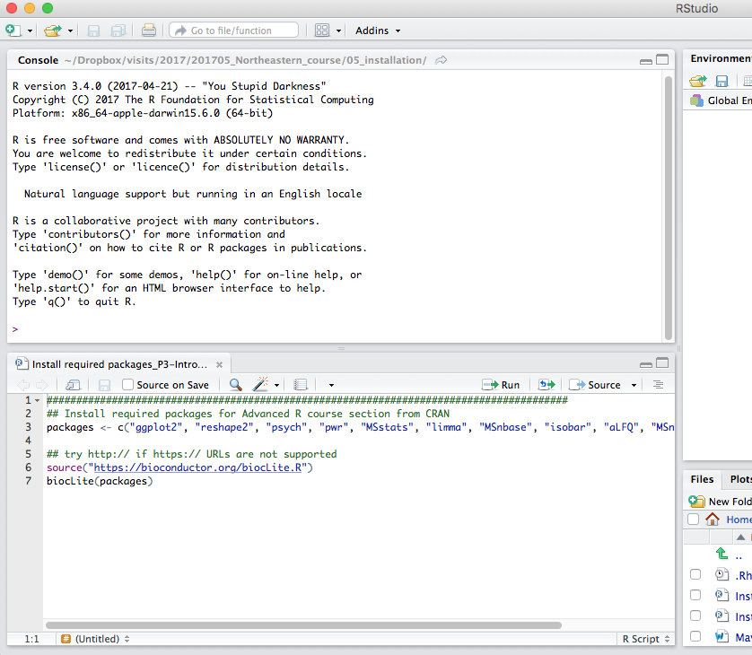

If all packages are installed, you can see similar at the end of Console like below. If you can see an error or different screen, please get back to us.

